How to Login Instruction Sheet for Teachers

- Login to www.thinkcentral.com
- Click on Mathematics.
- Click on Go Math (Top Row, 3rd from left).
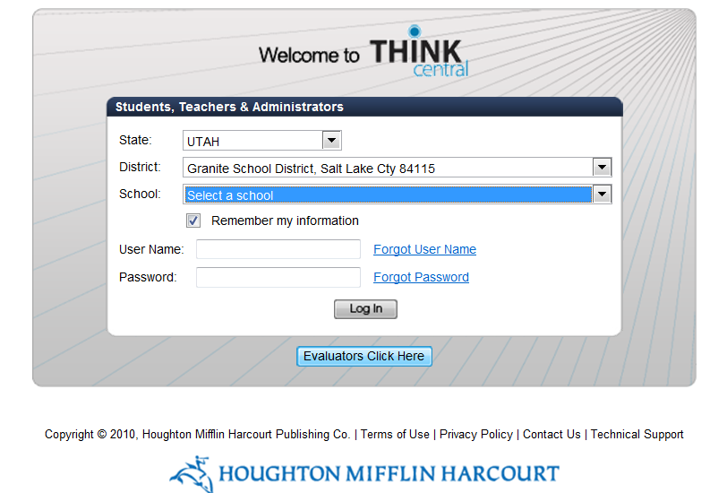
- Fill in State, District, and select your school. Check the Remember my information box so you will not need to fill this in each time. Enter your User Name and Password from the login lists provided to your school principal, secretary, and STS. Click Log In.

- Create password hints on the next screen.
- Become familiar with the options on the Homepage. More information to use Go Math! on ThinkCentral can be found on your grade level math websites.

